 | Abdi İpekçi Caddesi Kaşıkçıoğlu Apt. No:42 D:2 34365 Nişantaşı İstanbul  www.artxist.com  info@artxist.com  T. +90 212 291 77 84 F. +90 212 343 69 35 | PRESS RELEASE

x-plore Vol. II

This summer, x-ist is hosting the second “x-plore” group show, the first of which took place in 2010. The x-ist artists Ahmet Polat, Ali Elmacı, Ansen, Bahadır Baruter, Ceren Oykut, Erkut Terliksiz, Ekin Saçlıoğlu, Fatih Alkan, Seda Hepsev and Serkan Adın participate in x-plore Vol. II with their most recent works, none of which have been shown in Turkey before – they will be on display for the first time.

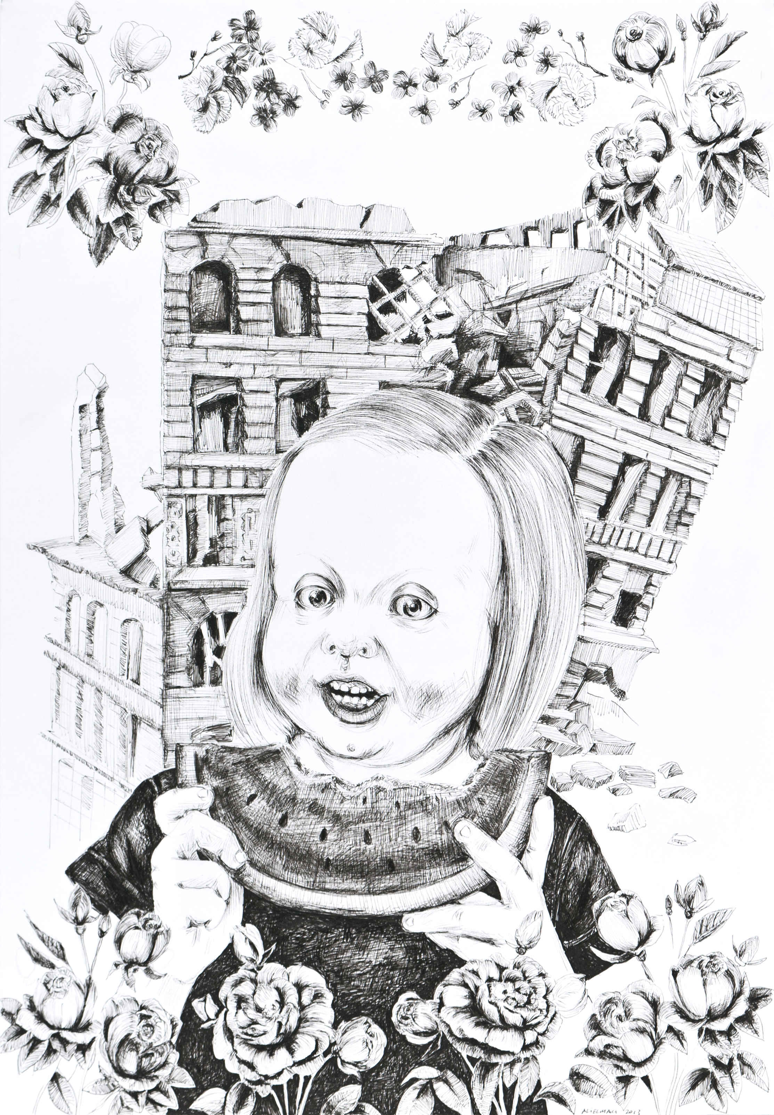

Ali Elmacı, “You Can’t Doubt My Love I”, Ink on paper, 50 x 35 cm, 2013

x-plore Vol. II can be visited between July 15th and September 3rd. It is a show that consists of works by x-ist artists, who work in various disciplines and with various media – and in this show we see them put the current status of their artistic production on display, in order to present the viewers with clues about how their upcoming shows during the next season are going to be like.

ICP award photographer Ahmet Polat has traveled to many cities throughout Turkey between the years 2006-2012 while working on his photography series titled “Kemal's Dream”, during which he has had discussions with his friends and the people he had just met, and took photos. Through Polat's own style, which is an interpretation of the traditional language of documentary photography, the series depict the youth of the republic enunciated by Atatürk, together with moments and situations from their lives. Previously unexhibited examples from this series can be seen in x-plore Vol. II.

Ali Elmacı depicts an up-to-date history of social problems without avoiding satirity or innuendo. In his works formed by his unique figurative and narrative language, he discusses the aspects of family, society, government, media and sacred values not visible to the naked eye by means of his own fiction and characters. Shown for the first time in x-plore Vol. II are a large scale canvas from his series “You'll Love Me As You Get To Know Me” and his brand new drawings.

In his works, which have caused much sensation both nationally and internationally, Ansen brings together various techniques and approaches such as photography, sculpture and painting. By manipulating real objects through digital editing and using the end results as different objects in his works, the artist sometimes questions a political or a social problem, and sometimes comes up with his own stories and characters. He's participating in x-plore Vol. II with his work “Cusei” which focuses on war strategies and centers of power of various regions.

Originally known as a caricaturist, Bahadır Baruter had shared with the viewers his mastery in drawing and painting with his previous shows “Existence Anxiety” (2006) and “Your Family is A Lie, Dear” (2012) in x-ist. The first piece of Baruter's new series “Why Does God Allow Evil?” is on display in x-plore Vol. II. Proceeding with his questioning of the taboos of the society by means of a humorous approach, Baruter utilizes religious similes, depicting people who are stuck at work in a desperate state, as if they've been crushed under the weight of their rituals.

Depicting her impressions regarding the city with an emphasis on urban architecture, Ceren Oykut dissects various elements and stories, and then unites them again. Different from her previous output, colorful works from her new series “Inside the Walls” are shown in x-plore Vol. II.

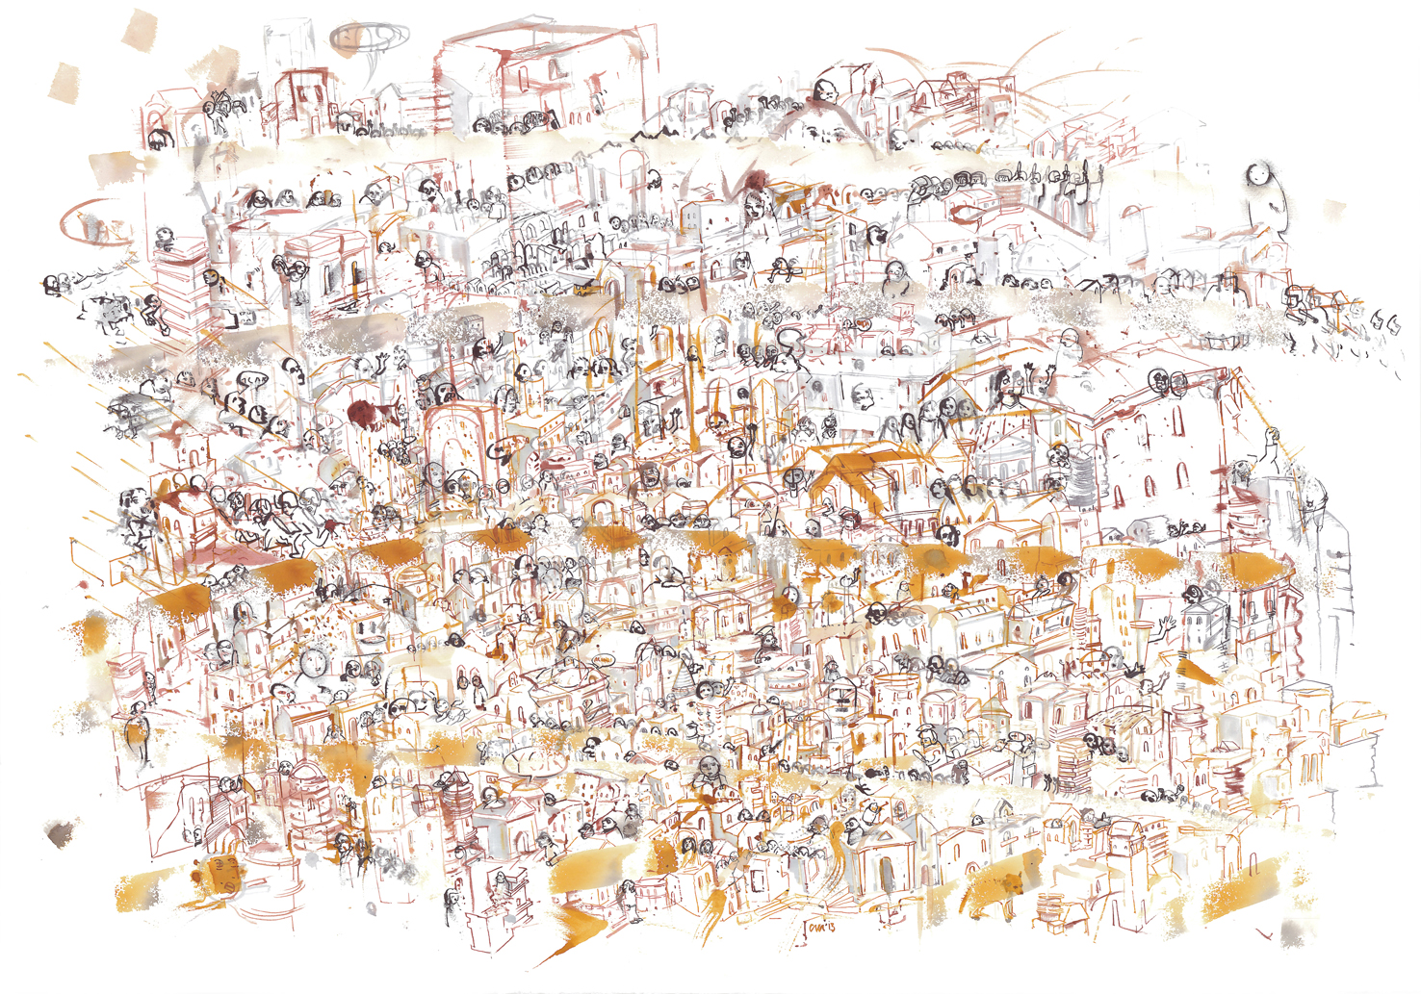

Ceren Oykut, “Inside the City Walls Series - Fingerprint”, Ink and water colours on paper, 70 x 100 cm, 2013

With her previous shows, Ekin Saçlıoğlu had questioned the reliability of memory and the relationship between dreams and reality, using sometimes a personal recollection, sometimes a story told by a friend as a starting point, calling attention to social issues by means of singular situations. Her work “Kingdom” shown in x-plore Vol. II is a combination of mixed media and holographic mosaics on canvas. It represents a disturbing kingdom that is situated between dreams and reality, comprising pleasant fictive characters.

For Erkut Terliksiz, painting is an experience, into which he is pulled by impulses he can not make sense of, nor control – and as he surrenders to these impulses he approaches insanity without actually going insane. His paintings comprise many emotions by making use of monsters coming into existence from dream states, and figures that roam between the real and the surreal. In this show, his new work “Time and Relative Dimension in Space” is on display.

Young photographer Fatih Alkan has just joined x-ist and had his first solo show in May 2013. Different from his previous work, he takes part in x-plore Vol. II with his black&white photography. With these photographs, the artist invites the viewer as a null-subject into the spaces he has reconstructed with light.

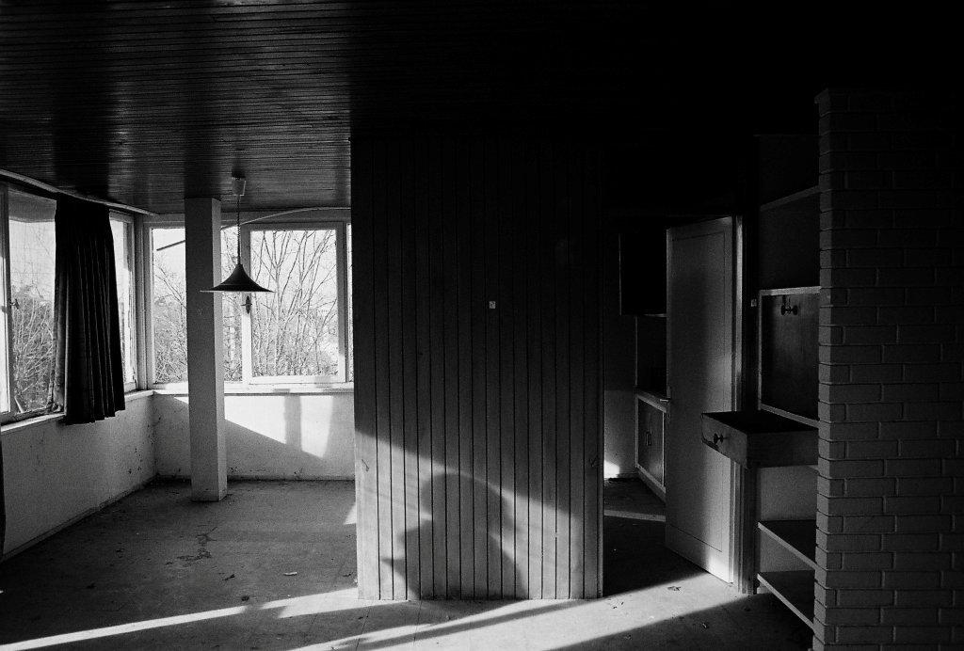

Fatih Alkan, “A Note At Your Home”, Photography, ed of 5, 55 x 82.5 cm, 2013

In the first show of the 2013-2014 season in x-ist, Lale Tara will be showing her new series of photographs titled “Everyone Carries A Shadow”. X-plore Vol. II hosts unexhibited examples from her “Doppelgänger (RUI)” series.

In her pencil drawings on paper, which bring together military uniforms in various combinations, Seda Hepsev questions the building of the identity of the male figure, through drawings of objects offered to boys as toys that represent the military institution –which exists as a result of the instigation of power, violence and competition.

Right after x-plore Vol. II, the first show of the 2013-2014 season in x-ist is by photographer Lale Tara, with her solo show “Everyone Carries a Shadow” opening September 10th.

